Paint by Numbers:
A Cost Effective Robotic Approach to Residential Painting

By: Student

Algonquin College
School of Advanced Technology

Paint by Numbers:
A Cost Effective Robotic Approach to Residential Painting

Prepared for Carolyn Côté
In partial fulfillment of the requirements of ENL1819T

By: Student
Algonquin College
School of Advanced Technology
Tuesday, April 12, 2011

Declaration of Sole Authorship
I, Student, confirm that this work submitted for assessment is my own and is expressed in my own words. Any uses made within it of the works of any other author, in any form (ideas, equations, figures, texts, tables, programs), are properly acknowledged at the point of use. A list of the references used is included.

Summary
The housing development industry has become more competitive due to the economic situation. Contractors need to find ways to reduce costs in order to stay competitive. The painting of interior rooms in high-rise buildings has always been done with manual labour. While spray gun technology is a better option compared to brushes and rollers, it does not eliminate the manual operation required.
This proposal outlines the benefits of an Autonomous Paint Robot (APR) to replace traditional manual painting when painting interior rooms in high-rise building. The APR will be able to paint the entire room without the help of a person. It does this in part by using the computer aided design (CAD) model of the room, and calculating the necessary gun trajectory and path to complete the painting. The general layout of these rooms does not vary much in the industry due to their efficient, cost effective designs, which reduces the amount of computer memory used by the APR to store the CAD models. The high-rise buildings were also chosen due to the ease of transportation of the APR by utilizing the service elevators.
An operator is still required to mask areas in the room that do not require painting. The operator is also responsible for initializing the startup of the APR, and also has the ability to manually control the APR. Once the APR starts up, it will move to one corner of the room and begin the painting process. It accomplishes the painting with the use of an airless spray gun attached to a robotic arm. It utilizes ultrasonic sensors to detect its distance from objects and steers itself accordingly. All commands are processed with a microcontroller and are based on the CAD models of the room.
The cost of the APR to paint a 100 room apartment complex is compared to two manual labourers painting the same apartment complex. The estimated cost for the APR is $10495.71, and the total cost when combined with one operator is $12339.71. The total cost for two manual labourers is $10076.00. While the cost of using the APR is higher, the overall time taken is half of that compared to the manual labourers.
It is concluded that the difference in cost is small compared to the amount of time saved when using the APR. By cutting the painting process time in half, it reduces the overall lead time for completion of the entire high-rise build. It is this time savings that can make the difference when bidding for building contracts.

Table of Contents
Declaration of Sole Authorship i
Summary ii
1.0 Introduction 1
2.0 Problem Background 2
3.0 Autonomous Paint Robot Operation 3
4.0 Autonomous Paint Robot Components 4
4.1 Controller 4
4.2 Wheel Movement 4
4.3 Robotic Arm 5
4.4 Linear Movement 6
4.5 Sensors 7
4.6 Spray Gun System and Specifications 7
4.7 CAD Based Programming 8
5.0 Cost Breakdown 9
6.0 Qualifications 11
7.0 Conclusions 12
Bibliography 13
Glossary 14

List of Figures and Tables
Figures
Figure 1: Example of Paint Coverage in a Corner [3] 3
Figure 2: Autonomous Paint Robot Components 4
Figure 3: PIC16F877A Microchip [4] 4
Figure 5: Robotic Arm Showing Joint Movement Directions 5
Figure 4: APR Showing Drive Wheels and Caster 5
Figure 6: Harmonic Drive Components [5] 6
Figure 7: Harmonic Drive after One Revolution [5] 6
Figure 8: Linear Movement and Telescoping Cylinders 6
Figure 9: Proper Spray Technique - Wrist Flex [3] 7
Figure 10: Example of Spray Pattern [6] 8
Figure 11: RobCAD Paint example [8] 8

Tables
Table 1: Estimated Cost Breakdown for APR 9
Table 2: Labour Cost to Paint an Apartment Complex 9
Table 3: Comparison between Manual Labour and APR 10

1.0 Introduction
The purpose of this report is to propose a solution to the problem of painting newly completed residential high-rise buildings. The housing development industry has always been competitive, and the recent economic situation has increased the need to reduce overall building costs.
One expense that is common to all contractors is the need to paint the interior rooms in these high-rise buildings. The challenge is to paint a large number of rooms in the shortest amount of time while maintaining the quality of the paint job. The current solution is to utilize manual labour to perform these painting tasks. Using a standard paint roller and brush provides a low-cost solution that requires minimal training. A more advanced technique uses an airless spray gun, which uses high pressure to atomize the paint to produce a fan pattern out of the spray gun. This technique requires more skill to effectively paint a surface, but can be more efficient and less time consuming than traditional painting techniques.
My proposed solution utilizes the airless spray gun technology, but eliminates the need for manual operation. An autonomous robot can be fitted with the airless spray gun technology to provide a more efficient and cost effective alternative to manual spray painting. The robot will have computer aided design (CAD) based programming that allows the floor plan of the room being painted to be loaded into the computer’s memory. Using the floor plan dimensions, the robot will have the ability to calculate the required paint spray trajectory and amount of paint required to provide full coverage.
This proposal includes the technical specifications for the airless spray gun used and an explanation of the CAD based programming. The autonomous robot design is discussed in terms of its control system, movement, robotic arm, sensors, spray gun output, and CAD based programming. Technical drawings are provided along with an overall cost estimate for the autonomous robot.
This report will be of importance to all housing contractors involved in residential high-rise building construction. Not only will there be a cost savings associated with labour, but there will be less potential for work-related injuries as the autonomous robot would eliminate any repetitive strain normally felt on the job.
While this proposal will focus on the design of the autonomous robot, it will not go into detail about paint mixing or multiple colours used in the painting process. It is assumed that the housing contractors will choose to paint the interior walls one neutral colour. The report will not discuss the housing market situation and it assumes that the proposed solution is viable regardless of the economic situation. While the painting of ceilings is possible with the APR, it is not discussed in this proposal.

2.0 Problem Background
Construction of residential high-rise buildings is a lucrative and highly competitive industry. New technology in building construction machines and materials has made it easier and cheaper to produce high-quality structures. One aspect in the development of these high-rise buildings that has not seen a technological breakthrough is the painting of interior rooms. Contractors have always relied on manual labour to paint the interior walls of each completed room. Multiple floors in high-rise buildings require a large number of rooms to be painted and therefore an increased number of manual labourers necessary to complete the painting. This can be very expensive and time consuming, and it does not come with a guarantee of quality.
Traditional painting techniques involve the use of paint brushes and rollers. These tools are cheap and require little to no training. Many professional painters will opt to use airless spray gun technology instead of the brush and roller. It is a more expensive option that requires more training to master, but can provide a more consistent paint application and be less time consuming with the right technique.
The disadvantage to both these techniques is that they utilize manual labour. This requires hiring qualified painters, providing training, and has the added element of potential injuries. My proposal is for an autonomous painting robot that utilizes spray gun technology. This will eliminate the need for manual labourers and will only require an operator to oversee the robot’s painting process.
High-rise buildings were chosen over houses because they have the most common floor plan designs. Developers will choose the most efficient and best selling floor plan, based on how easily the water, electrical, and heating lines can be installed [1]. Having more standardized floor plans reduces the amount of programs loaded into the autonomous paint robot which reduces memory usage.
Transporting the autonomous paint robot within a stand-alone house also poses a problem. Due to the weight of the robot, a scissor lift would be required to bring the robot to upper levels of a house. In a high-rise building, the robot can paint several units on one floor and take the service elevator to any additional levels that require painting [1]. This drastically reduces the time and cost of painting, which is why high-rise buildings were chosen.

3.0 Autonomous Paint Robot Operation
The autonomous paint robot (APR) is a robot that can be programmed with the floor plan of a room to be painted, and after an initial setup by an operator, will autonomously provide paint application to the desired surfaces. The room will require any undesired surfaces to be masked prior to operation. It is assumed that painting of the rooms will be done prior to installation of baseboards and doors, so masking would be limited to unmovable objects such as windows and electrical outlets.
When the robot is placed in the room, an operator will load the desired floor plan into the APR. Using a laser distance sensor, the robot will determine its current position compared to the dimensions listed in the floor plan. It will position itself at the starting point for painting based on the trajectory calculated using the CAD based programming. Its precise starting position is determined with the use of ultrasonic sensors mounted on the APR.
When the APR reaches the starting point, the robotic arm positions itself to provide the correct angle for the spray gun. The robotic arm is telescopic to allow for the height of the surface, up to a maximum height of 8 feet. The APR will begin painting from the top of the surface to the bottom, spraying from left to right. When it reaches its bottom position, the APR will move itself a distance equal to the width of the spray pattern, minus a preset amount. This preset amount is to account for the fact that the spray pattern is thinner at the edges of the spray, and therefore the coverage will be less at those spots. By moving a distance less than the overall width of the spray, the spots that have less coverage will be overlapped with the spray from the next application. The ideal overlap is at 75% of the fan width [2]
When the APR reaches a corner of the room, the programming will calculate the turning radius necessary to provide the same paint coverage. When painting a corner, the robotic arm will rotate the spray gun 90 degrees and paint from the top of the corner to the bottom. This will ensure proper coverage in the corner as well as both adjacent walls (see Figure 1).
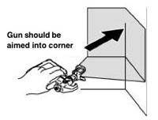
Upon completion of the paint job, the APR will emit a sound to alert the operator that the task is complete. Alerts will also sound in the case of robot impact, pressure loss in the spray, and a paint shortage.
Figure 1: Example of Paint Coverage in a Corner [3]

4.0 Autonomous Paint Robot Components
The autonomous paint robot (APR) will be made up of the following key components: controller, wheels, robotic arm, linear movement, sensors (built into the robot base), spray gun, and motor and piston pump assembly (see Figure 2). Concepts such as paint mixing, ceiling painting, and multiple colours will not be discussed. Not shown in the figure is the electrical cord supplying the APR, or the motors inside the robot base that drive the cylinders and linear movement.
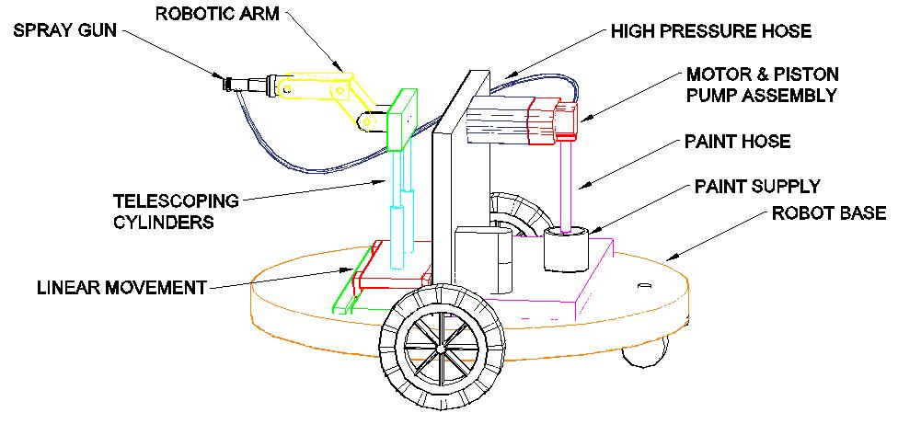
Figure 2: Autonomous Paint Robot Components

4.1 Controller
The control system is the most important component of the APR. It determines how the robot will autonomously move during the paint spray process, along with how each component will function with respect to one another. It also controls how the robotic arm reacts based on the spray pattern required.
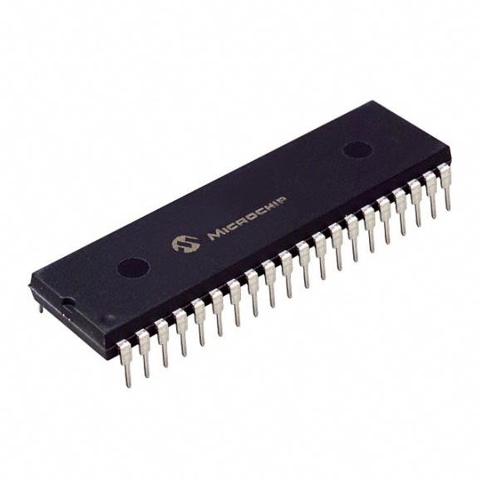
The APR uses a PIC16F877A microchip (see Figure 3) to control its processes. This microchip can receive signals from components on the APR such as the sensors and spray gun. The received signals are called inputs. The microchip can take these inputs and produce an output based on specific programming. For example, if the ultrasonic sensor detects an obstacle, it sends a signal to the microchip. The microchip interprets the signal and outputs a signal to the drive motors to reverse away from the obstacle.
Figure 3: PIC16F877A Microchip [4]

4.2 Wheel Movement
The APR consists of two drive wheels, and a rear caster (see Figure 4). The drive wheels are oriented in the centre of the left and right sides of the APR. Each wheel is powered by its own DC motor which allows the APR to steer, by alternating power to each motor. For example, powering just the right drive wheel turns the APR left. Powering just the left drive wheel turns the APR right. The rear caster swivels to provide smoother turning of the APR.
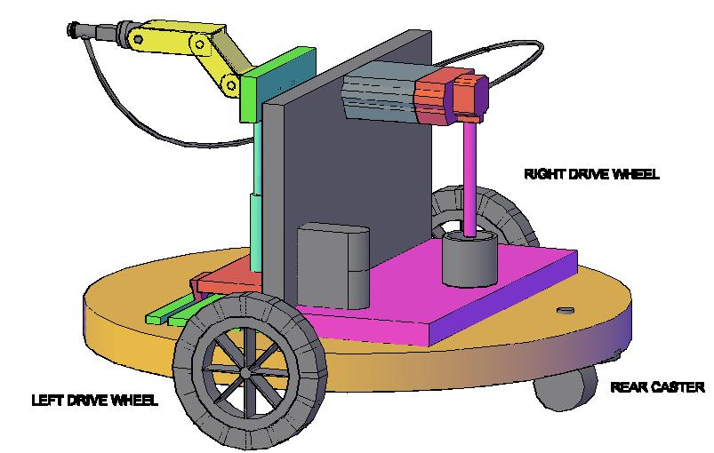
Figure 4: APR Showing Drive Wheels and Caster

4.3 Robotic Arm
The robotic arm is a jointed arm robot consisting of the following four joints: shoulder, elbow, wrist, and wrist roll (see arrow directions on Figure 5). These joints move just like the human arm, which is where their name is derived. Each joint is controlled by the microchip, and reacts according to the required painting condition. For example, when the robot encounters the corner of a room, the robotic arm will activate its wrist roll, causing the attached spray gun to rotate 90 degrees, achieving a different spray pattern.
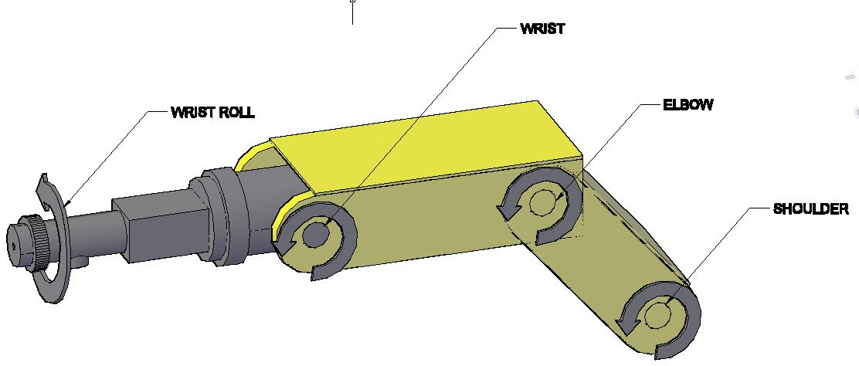
Figure 5: Robotic Arm Showing Joint Movement Directions
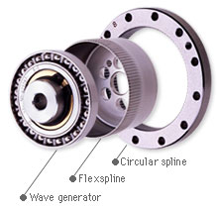
The joints are powered by harmonic drives. These drives consist of a wave generator, flexspline, and circular spline (see Figure 6). The flexspline has teeth which mesh with the circular spline. As the wave generator rotates, it causes the flexspline to deform into an elliptical shape. The elliptical shape means the teeth of the flexspline only mesh at certain points with the circular spline. The flexspline has two fewer teeth than the circular spline, meaning for every rotation of the wave generator, the flexspline moves counterclockwise by two teeth (compare arrows in Figure 7).
Figure 6: Harmonic Drive Components [5]
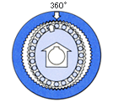
The harmonic drive has many advantages over traditional gear systems. Most notably for the use of the APR, the harmonic drive has almost no backlash. Backlash is an amount of lost motion between two meshed gears. Normally as gears rotate, there can be some slippage between the gears. Since in a harmonic drive the flexspline only meshes at specific points at all times, it limits the possibility of backlash. This is important in the robotic arm, as any lost motion during the paint spray process could result in a poor finish.
Figure 7: Harmonic Drive after One Revolution [5]

4.4 Linear Movement
To provide consistent paint application to the wall, the robot must be able to move from left to right while maintaining the same angle and distance from the wall. To accomplish this, the robotic arm is mounted to a block that can be shifted from left to right (see Figure 8). This block uses linear guide bearings to allow for smooth operation, which helps maintain the spray pattern.
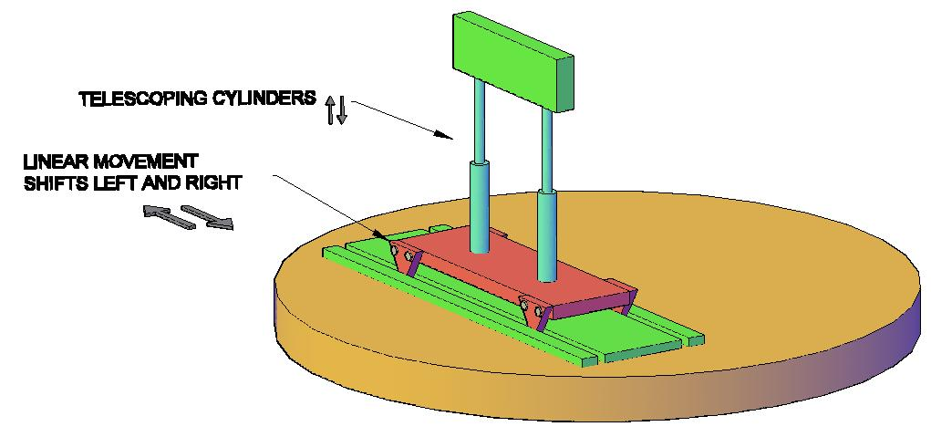
Figure 8: Linear Movement and Telescoping Cylinders
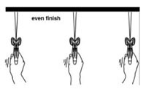
One of the hardest things to do with a manual airless spray gun is to maintain the correct distance and angle from the wall. Normally the operator would have to flex his or her wrist as their arm moves from left to right (see Figure 9). This is done to prevent an uneven paint finish. By building this functionality into the APR, it eliminates the probability of error during this left to right movement.
Figure 9: Proper Spray Technique - Wrist Flex [3]
The APR is required to move in an up and down fashion. After the APR completes its first left to right spray pass, it needs to shift downwards and complete a right to left pass. It continues this motion until it reaches the bottom of the wall. The APR accomplishes the vertical movement with the use of two telescopic cylinders attached to the linear block. These cylinders allow the robotic arm to reach a maximum height of 8 feet, which is sufficient to reach the standard room size [1].

4.5 Sensors
The APR needs to determine the correct distance from the wall to provide efficient paint spray application. This is done with the combination of laser distance and ultrasonic sensors. The laser distance sensor is used when moving to the initial painting position. It sends a beam of light towards an object – in this case a wall – and calculates the time taken for the beam to return to the sensor. It converts the time taken into a distance measurement.
The ultrasonic sensor is used by the APR to avoid hitting objects. This is accomplished by sending high frequency sound waves and determining the time taken for the echo to be heard. The APR has multiple ultrasonic sensors to continuously send these waves out while moving, each mounted within the robot base. The laser sensor is more effective while stationary, so the combination of laser and ultrasonic sensors provides the APR an effective method of distance measurement and object avoidance.

4.6 Spray Gun System and Specifications
While the microchip is the brains of the APR, the airless spray gun does all the physical work. The airless spray gun system consists of the following components: an electric motor to power the pump, the piston pump, the airless spray gun, and high pressure hose lines.
The 2.0 horsepower (HP), 120 volt (V) electric motor powers the piston pump. The size of the motor is important, as it has to be powerful enough to drive the piston pump to produce high pressures. The piston pump generates pressures up to 3300 pounds per square inch (PSI). It is this high pressure that causes the paint to atomize into fine particles, where they travel through the high pressure hose and into the spray gun.
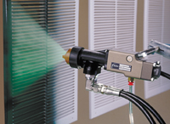
When the spray gun is activated, the fine paint particles exit from the nozzle with great velocity and a defined spray pattern. An example of a fan pattern from an airless spray gun is shown in Figure 10. The width of the spray can be controlled by regulating the pressure generated by the piston pump. The programming within the microchip will provide pressure and velocity settings to produce the ideal spray pattern. However, the operator has control to override these settings if desired. This can be done for situations where the thickness of the coat of paint is to be controlled (either thin or thick), or more commonly, when the area to be painted is narrow or wide.
Figure 10: Example of Spray Pattern [6]

4.7 CAD Based Programming
The APR uses programming based on the computer aided design (CAD) models of each room to be painted. The technology used is adapted from researchers at Michigan State University in the USA.
The theory behind CAD based programming is that by analyzing the design of an object – in this case, a room – the ideal spraying trajectory and velocity can be calculated. The process begins by gathering data on the CAD and spray gun models, as well as the required paint thickness [7]. It takes this information to develop a spray gun trajectory. This trajectory is then simulated using software called RobCAD Paint. RobCAD is a Siemens developed program that allows the “design, simulation, optimization, analysis, and off-line programming of robotic processes [8]”. The RobCAD Paint option allows the user to evaluate the entire spray process to determine the paint outcome without physically spraying any paint. Figure 11 is an example of the RobCAD Paint software (in this case on a vehicle). After the APR operator verifies the RobCAD Paint outcome, the trajectory is downloaded to the APR’s microchip, and the painting can begin.
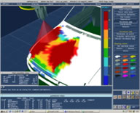
The majority of the research done by the researchers focuses on free-form objects (i.e. 3D objects rather than flat surfaces). However, the system behind free-form object paint trajectories applies to 2D objects as well. It works by dividing the surface that requires painting into several patches. By evaluating the surface in smaller sections, the accuracy of the trajectory is increased.
Figure 11: RobCAD Paint example [8]

5.0 Cost Breakdown
Table 1 is a breakdown of each component required to build the APR. The components chosen are those I have dealt with personally or that I know have been used in industry.
Table 1: Estimated Cost Breakdown for APR
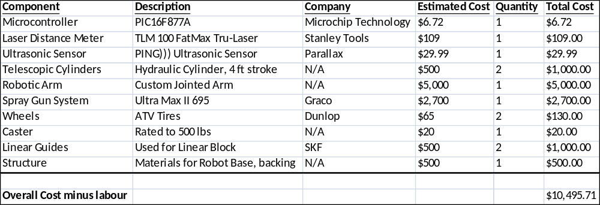
The microcontroller, laser distance meter, and ultrasonic sensor are components available to the general public. These components are easily integrated into any project based on knowledge gained in the robotics program.
The cost of the robotic arm and telescopic cylinders is estimated based on industry resale prices – educational purposes for the arm, and agricultural use for the cylinders. The APR will be custom built based on an existing spray gun system. In this case, the Graco Ultra Max II 695 will be used, as it includes features such as a built-in cleaning system and on-board digital displays [9] that will be useful on the APR. The existing spray gun will be used as an end effector for the robotic arm, while the motor and piston assembly will be mounted to the APR’s backing plate.
Table 2 is a calculation of the labour cost required for two painters to completely paint a 100 room apartment complex. The labour rate is taken from the government of Canada website for the Ottawa region [10]. It is assumed that it would take two hours to mask and paint each room. The cost of paint and equipment is not included in this cost.
Table 2: Labour Cost to Paint an Apartment Complex
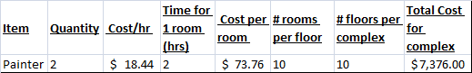
Table 3 shows a comparison between the two methods, assuming the painting crew uses an identical spray gun system as the APR. The overall difference is $2263.71 to paint an apartment complex. While the APR is more expensive than manual labour, the factors such as paint quality, fatigue, and potential for injury is still present with manual labour.
Table 3: Comparison between Manual Labour and APR
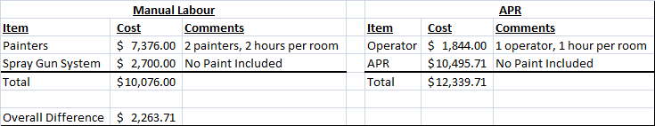
The most important calculation however is the total amount of time taken to complete the painting. While the manual labour is cheaper, it takes twice as long to paint one room than it would with the APR. That is a total of 200 hours to complete 100 rooms, while it takes only 100 hours for the APR to complete the job. It is also assumed in these calculations that only two labourers are used at a time. In order to match the painting speed of the APR, more painters would need to be hired, which is an additional cost.

6.0 Qualifications
I have a Bachelor of Applied Science in Mechanical Engineering from the University of Waterloo. I spent three years as an engineer in the manufacturing industry that included working in the Toyota paint shop. I gained firsthand knowledge of the robotic paint application process which aided in the design of the autonomous paint robot.
I will be a future graduate of the Electro-Mechanical Engineering Technician – Robotics program, which provides me with the technical knowledge of how to program and operate robots.
The combination of my work experience and education gives me the advantage of having both the theoretical background and the hands-on capability to provide the best end-product for the housing industry.

7.0 Conclusions
The Autonomous Paint Robot provides a high quality paint finish for interior rooms in high-rise buildings. It accomplishes this without the need for manual labour or training. Using state of the art technology such as CAD based programming and robotic arm control, the APR completes the paint job in half the time compared to manual labour.
Traditional spray gun systems can cost over $2500 and require operator training to become effective with it. There are no guarantees over the quality of the paint application, and repaints can increase costs dramatically. Manual painting can also require two labourers (one for masking and one for painting), which brings the total cost over $10000 for a 100 room apartment complex.
At just over $10000, the APR provides a superior paint finish at a comparable cost. By completing the paint job in half the time, it allows contractors to improve their lead times for overall completion of the building project. Time is invaluable in the housing development industry, and the APR can be the difference between winning and losing contract bids.

Bibliography
- Interview with R. McKenna, Masters Student in Architecture, University of Toronto, at Toronto, March 2011.
- G. L. Jepsen. “DuPont Application Training,” [Training Document] DuPont Herberts Automotive Systems, glj-rev #11-02/2003, 2003.
- CJ Spray Inc., “Airless Spray Technique”, http://www.cjspray.com/homeowner-sprayers/how-to/use-a-sprayer/airless-spray-technique.html, Accessed: April 6, 2011.
- DigiKey Corporation, “PIC16F877A-I/P-ND”, http://media.digikey.com/photos/Microchip%20Tech%20Photos/150-40-DIP.jpg, Accessed: March 31, 2011.
- Harmonic Drive Systems Inc., “Principles of Harmonic Drive”, http://www.hds.co.jp/HDS_hp_english/english/principle/index.html,
Accessed: April 7, 2011.
- Nordson Corporation, “Prism Automatic Spray Guns”, http://www.nordson.com/en-us/divisions/industrial-coating/products/liquid-coating-products/Non-Electrostatic-Spray-Systems/Pages/Prism-Automatic-Spray-Guns.aspx, Accessed: April 7, 2011
- H. Chen and N. Xi, “Automated tool trajectory planning of industrial robots for painting composite surfaces,” in International Journal of Advanced Manufacturing Technology, Vol. 35, Dordrecht, Netherlands: Springer Science & Business Media B.V., 2007, pp. 680-696.
- Siemens Product Lifecycle Management Software Inc., “Tecnomatix - Siemens PLM Software”, http://www.ugs.jp/product/tecnomatix/em-workplace_pc.html, Accessed: April 3, 2011.
- Graco Inc., “Graco Ultra Max II 695 Electric Airless Sprayer”, http://www.graco.com/Internet/T_PDB.nsf/SearchView/UltraMaxII695#tab5Tab, Accessed: April 7, 2011.
- Human Resources and Skills Development Canada, “Schedule of Wage Rates: Ontario - Ottawa Zone”, http://www.hrsdc.gc.ca/eng/labour/employment_standards/contracts/schedule/ontario/east_zone/schedule.shtml, Updated: June 30, 2010, Accessed: April 7, 2011.

Glossary
APR: Abbreviation for Autonomous Paint Robot
Autonomous Robot: A robot that moves and makes decisions without the aid of an operator
Backlash: Lost motion occurring in gear systems
CAD: Abbreviation for Computer Aided Design
Circular Spline: Component of a harmonic drive.
End effector: Any type of tool mounted to the end of a robotic arm
Flexspline: Component of a harmonic drive. Have fewer teeth than the circular spline
Harmonic Drive: Type of gear system consisting of a wave generator, flexspline, and circular spline.
Ultrasonic sensor: Sensor that emits high frequency sound waves and detects the time taken to receive an echo.
Wave generator: Component of a harmonic drive. Causes the flexspline to deform.

